**Experiment 1.**

**Aim : Configuration and administration of IIS and Apache Web Server.**

Following are the steps to set up **IIS SERVER :**

1. Right-click on the Windows button on the bottom-left corner and select **Run** and type in appqiz.cpl and hit enter.

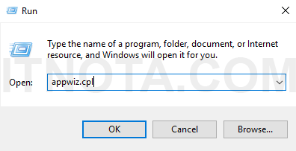

1. As soon as a new window called **Programs and Features** is opened, click on the link **Turn Windows features on or off**.

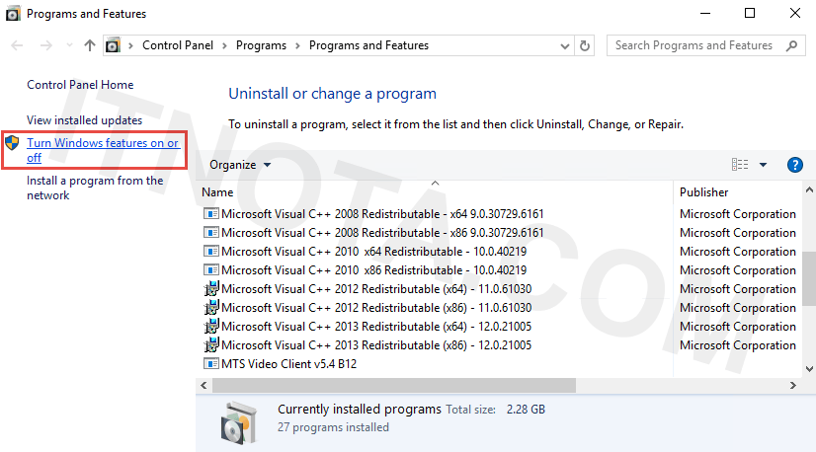

1. Click on the **Internet Information Services** checkbox. By default it will install all you need to host a website. Once done, click **OK** and **Close** when it says “Windows completed the requested changes.”

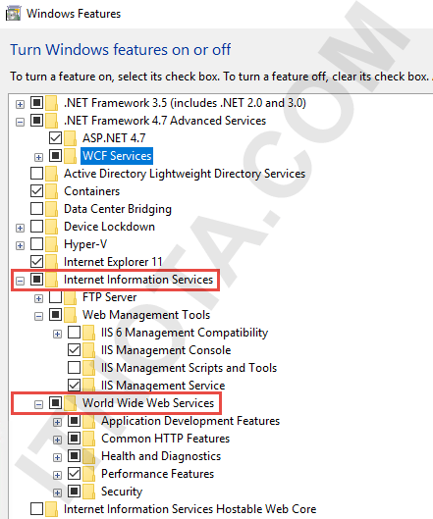

1. Now open your browser and type in **localhost** and press **ENTER**. You should see a default web page is rendered in your browser.

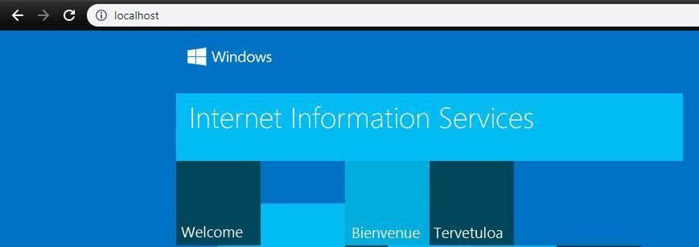

Now we will set up apache server using ***Xampp*** app , following steps will do the same :

* + - 1. Download Xampp from “<https://www.apachefriends.org/download.html>”.
      2. Install the xampp.exe file and open up the app.
      3. Click on start button right after the ‘Apache’ to start apache services.

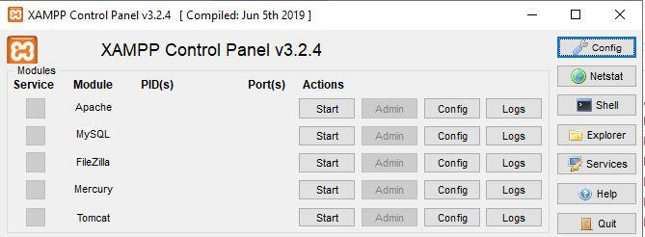

**Experiment 2.**

**Aim : Develop an HTML page to demonstrate the use of basic HTML tags.**

Following code Demonstrates the use of basic html tags :

<!DOCTYPE html>

<html>

<head>

<title>Basic Html tags</title>

</head>

<body>

<h1>Heading h1</h1> <!-- headings -->

<h2>heading h2</h2>

<h3>heading h3</h3>

<h4>heading h4</h4>

<h5>heading h5</h5>

<h6>heading h6</h6>

<p>this is inside a paragraph tag</p> <!-- paragraph tag -->

<a href="about.html">This is a link to another page using anchor tag</a> <!-- anchor tag -->

<hr/>this is after using horizontal ruler tag

<div> <!-- using div tag -->

<ul> <!-- lists -->

<li>unordered <span style="color: #ff0000;">list</span> element 1</li> <!-- span tag -->

<ol>

<li>ordered list element 1</li>

<li>element 2</li>

</ol>

<li>UO list elemnt 2</li>

<ol>

<li> element 1 </li>

<li>element 2 </li>

</ol>

</ul>

</div>

<img src="" alt="gne image"> <!-- image tag -->

</body>

</html>

<p> = this tag is used to create a paragraph.

<a> = link a web page to another web page using this tag.

<h1> to <h6> = used to define different heading sizes.

<img> = used to insert an image.

<hr> = used to insert a horizontal ruler.

<ul> = unordered list, <ol> = ordered list, <li> = list item.

<div> = used to divide page, doesn’t affect layout

<span> = used for grouping and applying styles to inline elements

**OUTPUT :**

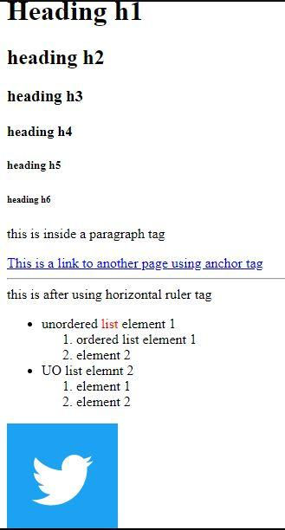

**Experiment 3.**

**Aim : Create an HTML file to link to different HTML page and also link within a page.**

Following code Demonstrates the use of basic html tags : >

<!DOCTYPE html>

<html>

<head>

<title>Basic Html tags</title>

</head>

<body>

<a href="#myimages">Linking within page</a><hr>

<a href="about.html">link to another page</a>

<h1>Heading h1</h1> <!-- headings -->

<h2>heading h2</h2>

<h3>heading h3</h3>

<h4>heading h4</h4>

<h5>heading h5</h5>

<h6>heading h6</h6>

<p>this is inside a paragraph tag</p> <!-- paragraph tag -->

<a href="about.html">This is a link to another page using anchor tag</a> <!-- anchor tag -->

<hr/>this is after using horizontal ruler tag

<div> <!-- using div tag -->

<ul> <!-- lists -->

<li>unordered <span style="color: #ff0000;">list</span> element 1</li> <!-- span tag -->

<ol>

<li>ordered list element 1</li>

<li>element 2</li>

</ol>

<li>UO list elemnt 2</li>

<ol>

<li> element 1 </li>

<li>element 2 </li>

</ol>

</ul>

</div>

<img src="images/twitter.jpg" alt="twitter" id = "myimages"> <!-- image tag -->

</body>

</html>

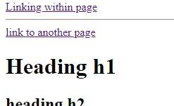

**Output :**

There are two links, one will open up a new html page another will take you to the image below.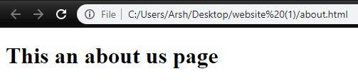

**Experiment 4.**

**Aim : Write an HTML file to demonstrate the insertion of images.**

Following html will add an image to web page : >

<!DOCTYPE html>

<html>

<head>

<title>Setting up an image</title>

</head>

<body>

<img src="images/gne.jpg" alt="gne images" width="500" border="3px">

</body>

</html>

Attributes :

Src = used to specify location of image.

Alt = value assigned to alt will appear when image fails to load.

Width = width of image in pixels.

Height = height of image in pixels.

Border = used to add border to image.

**Output :**

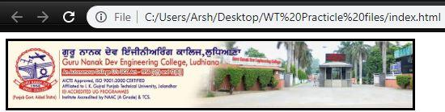

**Experiment 5.**

**Aim : Demonstrate the creation of tables in a web page using HTML.**

Following code will demonstrate use of tables : >

<!DOCTYPE html>

<html>

<head>

<title>Tables and Frames</title>

</head>

<body>

<table border = "2px" >

<tr>

<td>

Name

</td>

<td>

Class

</td>

<td>

Roll no

</td>

</tr>

<tr>

<td>

Arsh

</td>

<td>

CSE1

</td>

<td>

1706406

</td>

</tr>

<tr>

<td>

Student

</td>

<td>

CSE2

</td>

<td>

1706407

</td>

</tr>

</table>

</body>

</html>

**Output :** 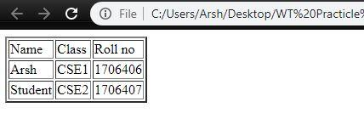

**Experiment 6.**

**Aim : Develop a registration form by using various form elements like input box, text area, radio buttons, check boxes etc.**

Following code will produce a Form : >

<!DOCTYPE html>

<html lang="en">

<head>

<title>Music</title>

<link rel="stylesheet" type="text/css" href="styles/main_style.css">

</head>

<body>

<div class="super_container">

<!-- Header -->

<header class="header">

<div class="logo">

<img src="images/logo.png" style="height: 100px; width: 100px">

</div>

<div>

<span class="logo_text">Music</span>

</div>

<div style="margin-left: 30%;">

<!-- Main Navigation -->

<nav class="topnav">

<ul>

<li class="active"><a href="index.html">Home</a></li>

<li><a href="artists.html">Artists</a></li>

<li><a href="blog.html">Latest Release</a></li>

<li><a href="contact.html">Contact</a></li>

</ul>

</nav>

<!-- User area -->

<div class="topnav" style="margin-left: 20%; float: left;">

<ul>

<li><a href="login.html">Login</a></li>

<li><a href="register.html">Register</a></li>

</ul>

</div>

</div>

</header>

</div>

<div style="margin-top: 10%;">

<center>

<h1 style="color: #3b125d">Registration Form</h1>

<form style="font-size: 19px; border-width: 2px; border-radius: 5px; width: 30%; padding: 20px; background-color: #f2f2f2;" action=”submit.html”>

<table>

<tr>

<td><br>Name: </td>

<td><br><input type="text" id="name" required style="width: 200px; height: 20px;" placeholder="Enter your name..."></td>

</tr>

<tr>

<td><br>Email ID: </td>

<td><br><input type="email" id="email" required style="width: 200px; height: 20px;" placeholder="Enter your email id..."></td>

</tr>

<tr>

<td><br>Age: </td>

<td><br>

<input type="number" id="age" required style="width: 200px; height: 20px;" placeholder="Enter your age..."></td>

</tr>

<tr>

<td><br>Gender: </td>

<td> <br>

<select>

<option>Male</option>

<option>Female</option>

<option>Trans-Gender</option>

</select>

</td>

</tr>

<tr>

<td><br>Music Genre: </td>

<td><br>

<input type="checkbox" name="hiphop" value="hiphop"> Hip Hop<br>

<input type="checkbox" name="jaz" value="jaz"> Jaz<br>

<input type="checkbox" name="rock" value="rock" checked>Rock<br>

<input type="checkbox" name="electro" value="electro">Electro<br>

<input type="checkbox" name="electronic" value="electronic">Electronic<br>

<input type="checkbox" name="pop" value="pop" checked>Pop<br></td>

</tr>

<tr>

<td><br>Password: </td>

<td><br><input type="password" id="password" required style="width: 200px; height: 20px;" placeholder="Set a password..."></td>

</tr>

</table>

<br>

<button>SUBMIT</button>

</form>

</center>

</div>

</body>

</html>

**Output :**

* Clicking the send button will redirect us to a new page specified in action attribute of <form>.

**Experiment 8.**

**Aim : Design an HTML page by using the concept of internal, inline, external style sheets.**

Following code will illustrate use of inline, internal and external style sheets :>

## **External CSS**

External styles are defined within the <link> element, inside the <head> section of an HTML page:-

<!DOCTYPE html>

<html>

<head>

<link rel="stylesheet" type="text/css" href="mystyle.css">

</head>

<body>

<h1>Hello</h1>

<p>This is my new webpage</p>

</body>

</html>

**Here is how the "mystyle.css" file looks like:**

### **"mystyle.css"**

**body {  
  background-color: lightblue;  
}  
  
h1 {  
  color: navy;  
  margin-left: 20px;  
}**

**Output:**

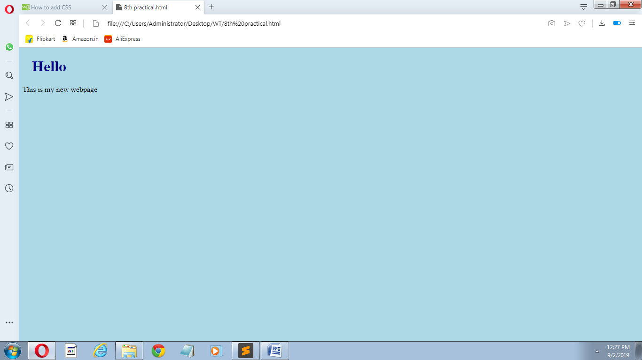

## **Internal CSS**

Internal styles are defined within the <style> element, inside the <head> section of an HTML page:

<!DOCTYPE html>

<html>

<head>

<style>

body {

background-color: linen;

}

h1 {

color: maroon;

margin-left: 40px;

}

</style>

</head>

<body>

<h1>Hey</h1>

<p>This is internal.</p>

</body></html>

**Output:**

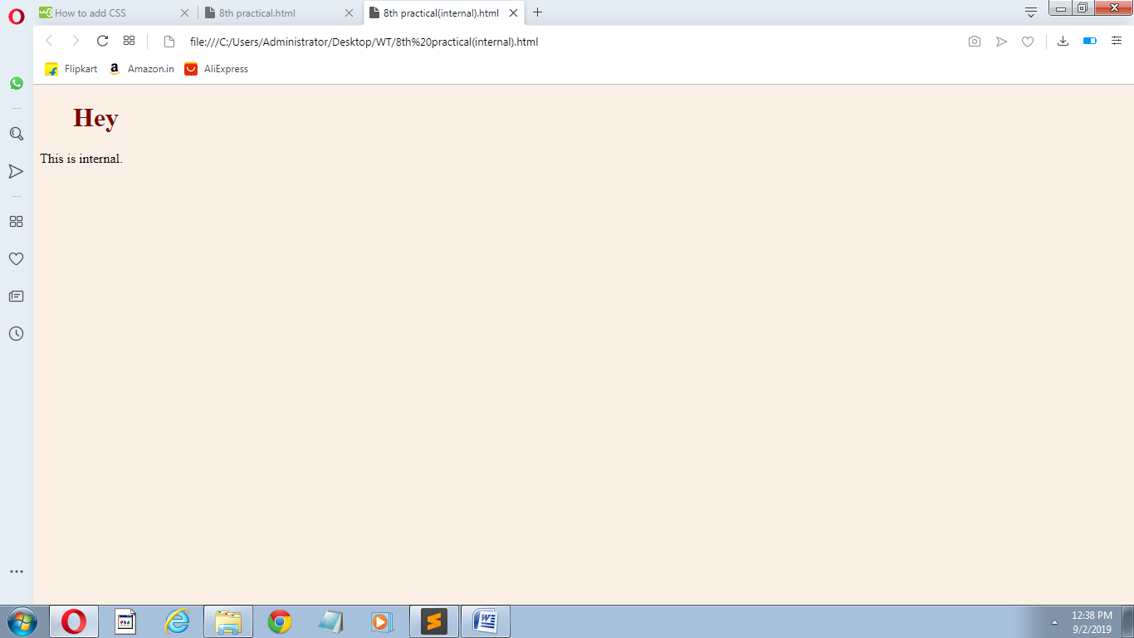

## **Inline CSS**

Inline styles are defined within the "style" attribute of the relevant element:

**<!DOCTYPE html>**

**<html>**

**<body>**

**<h1 style="color:blue;text-align:center;">Hi</h1>**

**<p style="color:red;">This is inline.</p>**

**</body>**

**</html>**

**Output:**

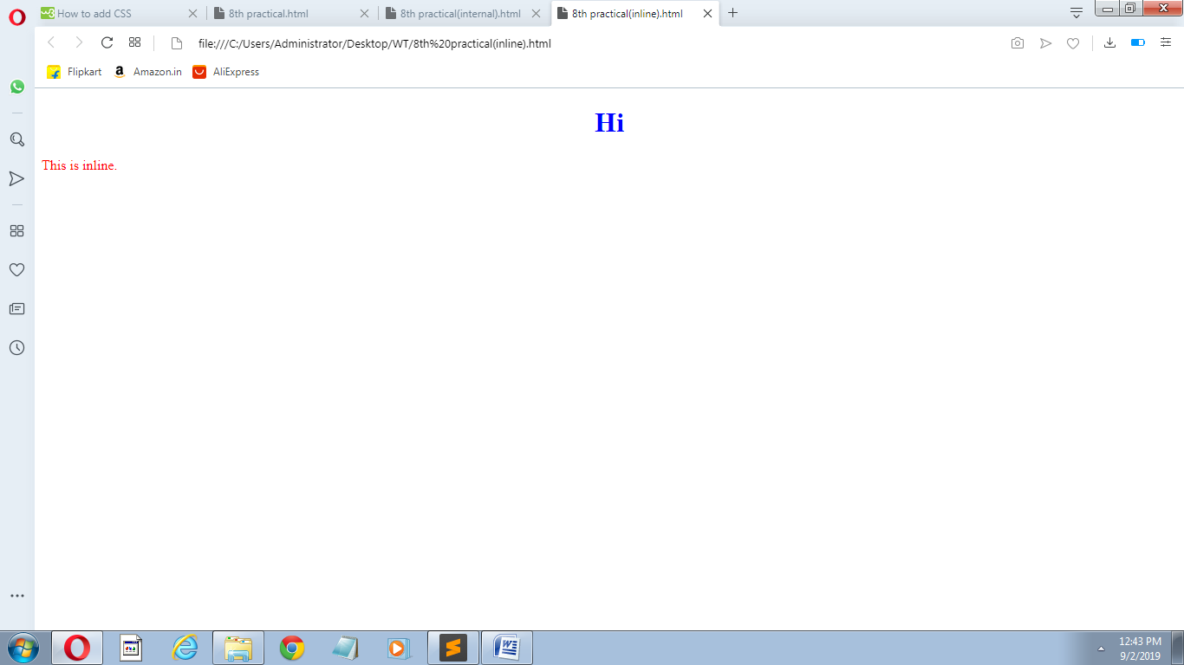

**Experiment 9.**

**Create a html file to implement the styles related to text, fonts, links using CSS.**

Following code will illustrate styles related to text,fonts,links using css :>

**Styles related to text using css:>**

**<!DOCTYPE html>**

**<html>**

**<head>**

**<style>**

**body {**

**color: blue;**

**}**

**h1 {**

**color: green;**

**}**

**p.uppercase {**

**text-transform: uppercase;**

**}**

**div {**

**border: 1px solid black;**

**padding: 10px;**

**width: 200px;**

**height: 300px;**

**text-align: justify;**

**}**

**</style>**

**</head>**

**<body>**

**<h1>Hey</h1>**

**<p class="uppercase">This is css text.<br>**

**We are justifying the text.</br></p>**

**<div>Lorem ipsum dolor sit amet, consectetur adipisicing elit, sed do eiusmod**

**tempor incididunt ut labore et dolore magna aliqua. Ut enim ad minim veniam,**

**quis nostrud exercitation ullamco laboris nisi ut aliquip ex ea commodo**

**consequat. Duis aute irure dolor in reprehenderit in voluptate velit esse**

**cillum dolore eu fugiat nulla pariatur. Excepteur sint occaecat cupidatat non**

**proident, sunt in culpa qui officia deserunt mollit anim id est laborum.</div>**

**</body>**

**</html>**

**Output:-**

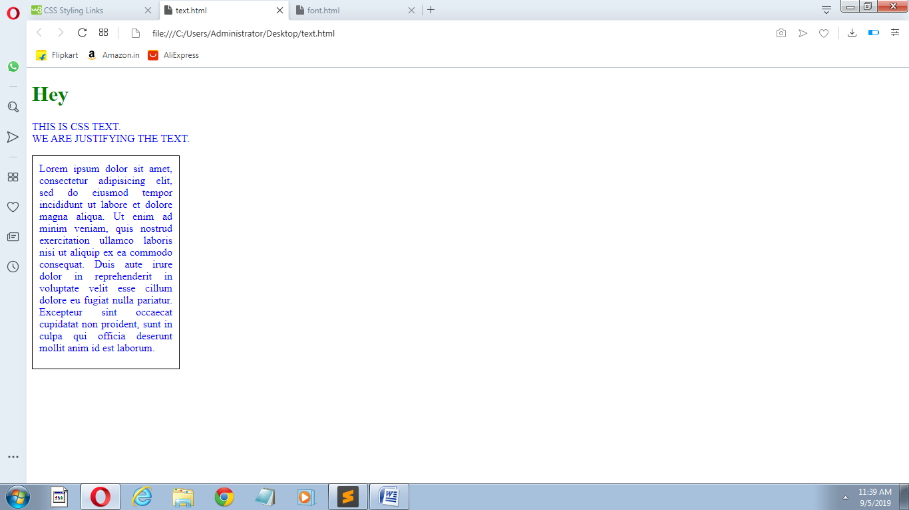

**Styles related to font using css:>**

**<!DOCTYPE html>**

**<html>**

**<head>**

**<style>**

**body {**

**font-size: 100%;**

**}**

**h1 {**

**font-size: 40px;**

**}**

**p.serif {**

**font-family: "Times New Roman", Times, serif;**

**}**

**</style>**

**</head>**

**<body>**

**<h1>Hello</h1>**

**<p class="serif">This is css font.</p>**

**</body>**

**</html>**

**OUTPUT:>**

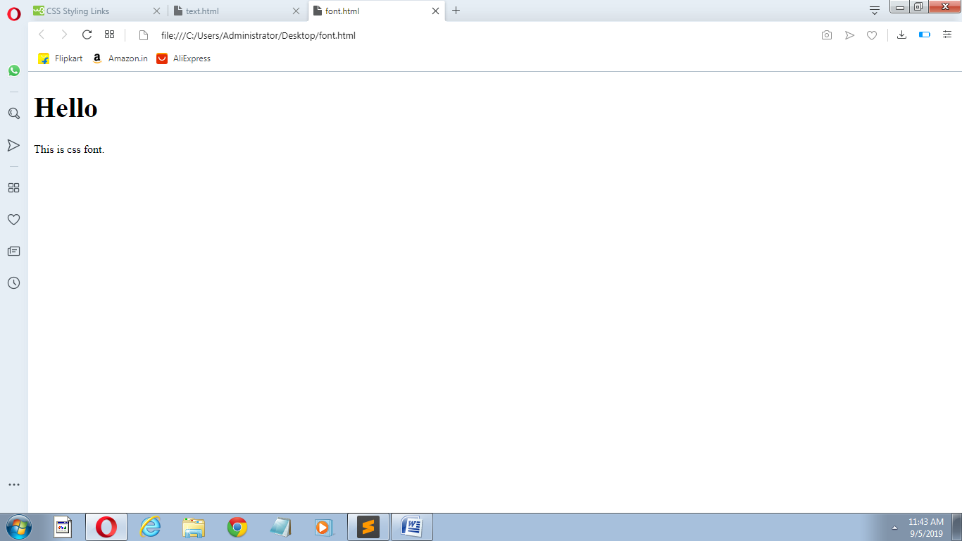

**Styles related to link using css:>**

**<!DOCTYPE html>**

**<html>**

**<head>**

**<style>**

**a:link, a:visited {**

**background-color: #f44336;**

**color: white;**

**padding: 14px 25px;**

**text-align: center;**

**text-decoration: none;**

**display: inline-block;**

**}**

**a:hover, a:active {**

**background-color: red;**

**</style>**

**</head>**

**<body>**

**<p><b><a href="9th practical(text).html">This is a link</a></b></p>**

**</body>**

**</html>**

**Output:>**

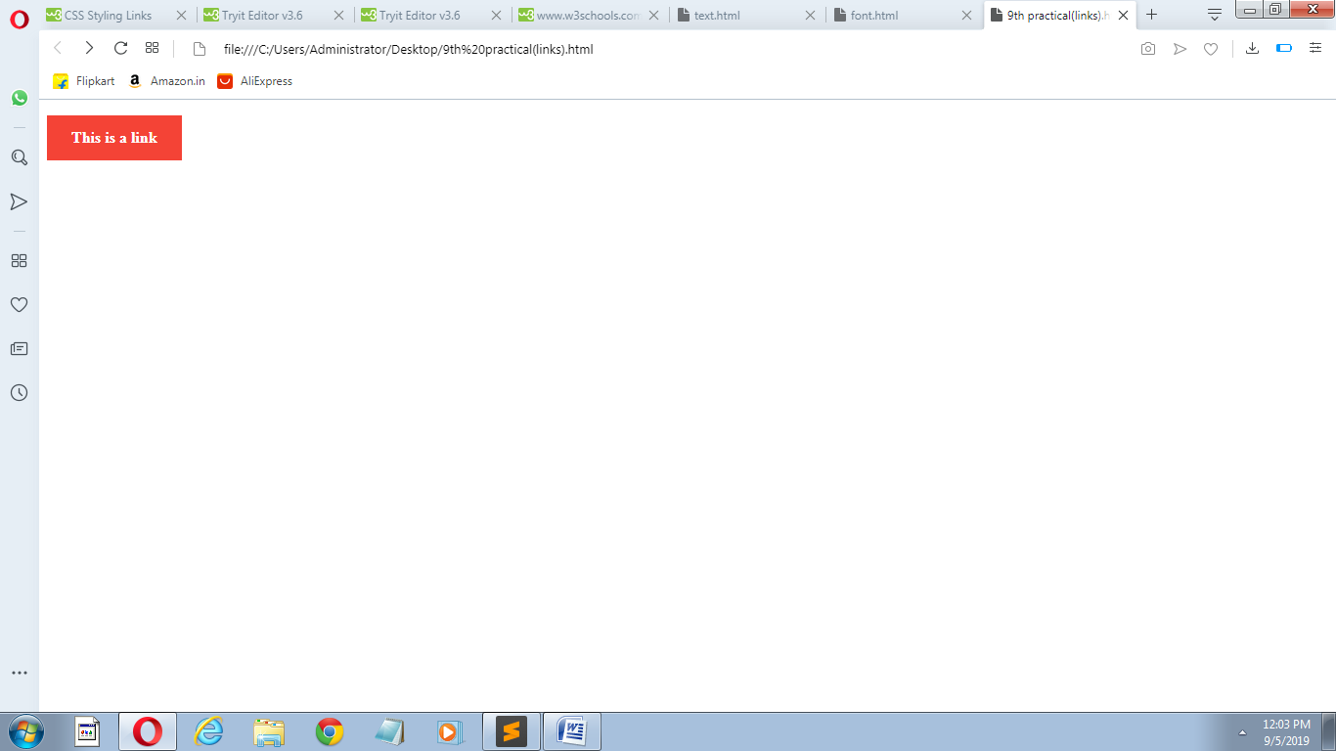

**Experiment 10.**

**Develop an HTML file to implement styles related to lists,tables using css.**

Following code will illustrate styles related to lists,tables using css :>

**Styles related to lists using css:>**

**<!DOCTYPE html>**

**<html>**

**<head>**

**<style>**

**ol {**

**background: #ff9999;**

**padding: 20px;**

**}**

**ul {**

**background: #3399ff;**

**padding: 20px;**

**}**

**ol li {**

**background: #ffe5e5;**

**padding: 5px;**

**margin-left: 35px;**

**}**

**ul li {**

**background: #cce5ff;**

**margin: 5px;**

**}**

**</style>**

**</head>**

**<body>**

**<h1>Styling Lists With Colors:</h1>**

**<ol>**

**<li>Coffee</li>**

**<li>Tea</li>**

**<li>Coca Cola</li>**

**</ol>**

**<ul>**

**<li>Coffee</li>**

**<li>Tea</li>**

**<li>Coca Cola</li>**

**</ul>**

**</body>**

**</html>**

**Output:>**

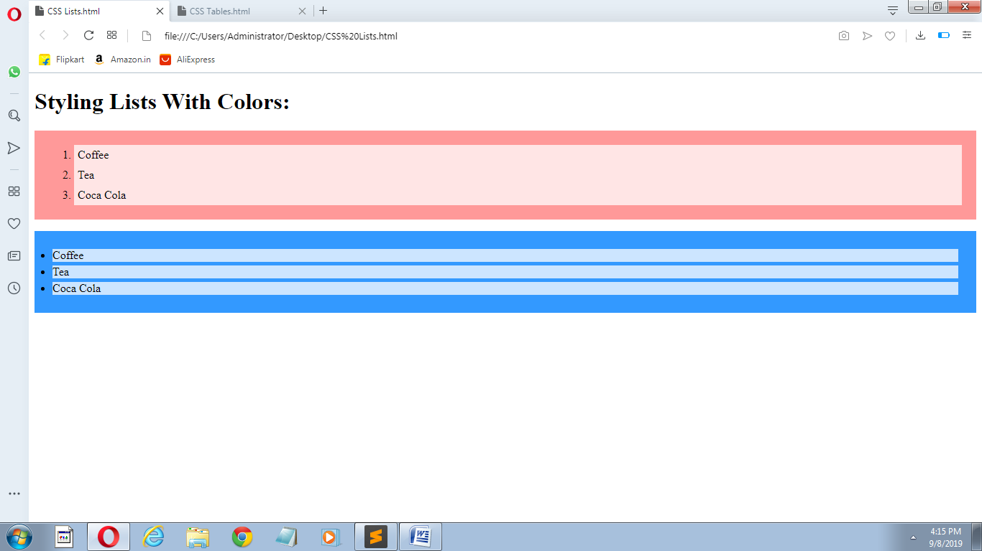

**Styles related to tables using css:>**

**<!DOCTYPE html>**

**<html>**

**<head>**

**<style>**

**table {**

**border-collapse: collapse;**

**width: 100%;**

**}**

**th, td {**

**text-align: left;**

**padding: 8px;**

**}**

**tr:nth-child(even) {background-color: #f2f2f2;}**

**</style>**

**</head>**

**<body>**

**<div style="overflow-x:auto;">**

**<table>**

**<tr>**

**<th>First Name</th>**

**<th>Last Name</th>**

**<th>Points</th>**

**<th>Points</th>**

**<th>Points</th>**

**<th>Points</th>**

**<th>Points</th>**

**<th>Points</th>**

**<th>Points</th>**

**<th>Points</th>**

**<th>Points</th>**

**<th>Points</th>**

**</tr>**

**<tr>**

**<td>Jill</td>**

**<td>Smith</td>**

**<td>50</td>**

**<td>50</td>**

**<td>50</td>**

**<td>50</td>**

**<td>50</td>**

**<td>50</td>**

**<td>50</td>**

**<td>50</td>**

**<td>50</td>**

**<td>50</td>**

**</tr>**

**<tr>**

**<td>Eve</td>**

**<td>Jackson</td>**

**<td>94</td>**

**<td>94</td>**

**<td>94</td>**

**<td>94</td>**

**<td>94</td>**

**<td>94</td>**

**<td>94</td>**

**<td>94</td>**

**<td>94</td>**

**<td>94</td>**

**</tr>**

**<tr>**

**<td>Adam</td>**

**<td>Johnson</td>**

**<td>67</td>**

**<td>67</td>**

**<td>67</td>**

**<td>67</td>**

**<td>67</td>**

**<td>67</td>**

**<td>67</td>**

**<td>67</td>**

**<td>67</td>**

**<td>67</td>**

**</tr>**

**</table>**

**</div>**

**</body>**

**</html>**

**Output:>**

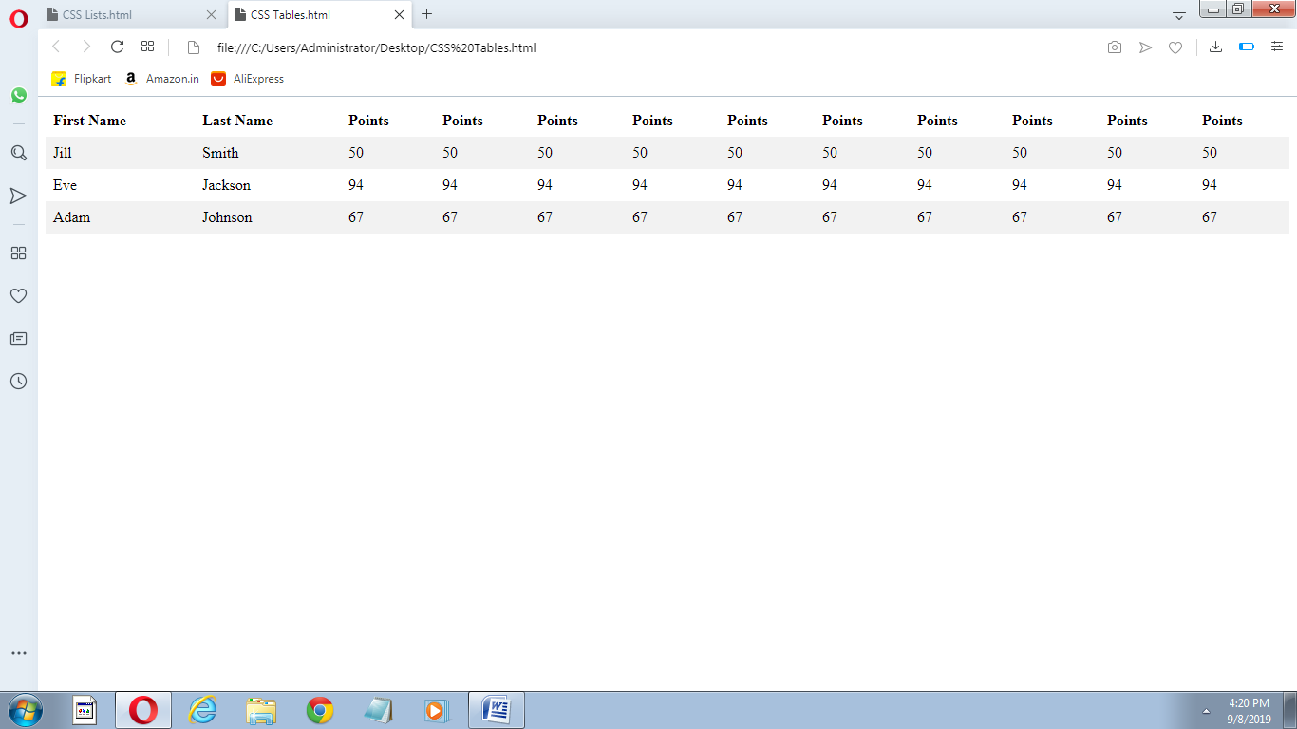

**Experiment 11.**

**Create an HTML page to implement concept of DOM using javascript.**

Following code will implement concept of DOM using javascript:>

**<html>**

**<head>**

**<title>DOM</title>**

**</head>**

**<body>**

**<h1 id="one">Welcome</h1>**

**<p>This is the welcome message.</p>**

**<script type="text/javascript">**

**var text = document.getElementById("one").innerHTML;**

**alert("The first heading is " + text);**

**</script>**

**</body>**

**</html>**

**Output:>**

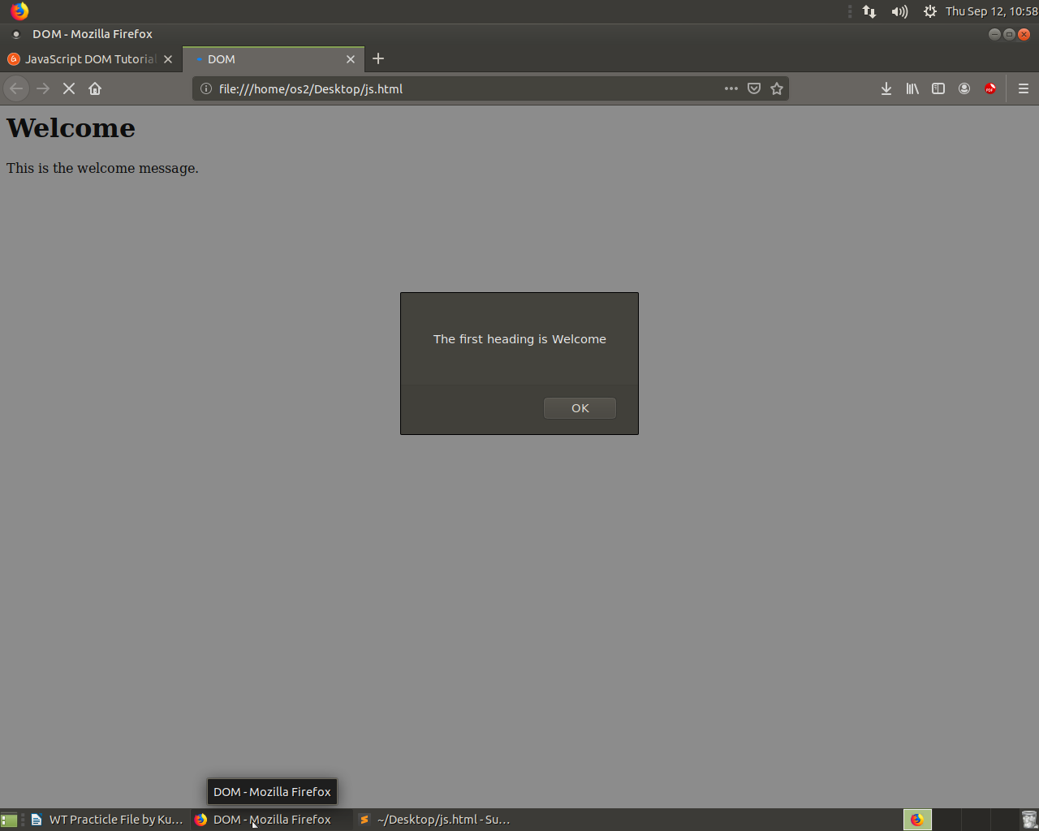

**Experiment 12.**

**Create an HTML file to display various arithmetic operations on variables in javascript.**

Following code will display various arithmetic operations on variables in javascript:>

**<!DOCTYPE html>**

**<html>**

**<head>**

**<title>Javascript Arithmetic Operators</title>**

**</head>**

**<body>**

**<h1>Performing Arithmetic Operations </h1>**

**<script>**

**var a = 12, b = 3;**

**var add, sub, multiply, divide, mod;**

**add = a + b; //adding 3 and 12.**

**sub = a - b; //subtracting 3 from 12.**

**multiply = a * b; //Multiplying both the numbers.**

**divide = a / b; //dividing 12 by 3.**

**mod = a % b; //calculating the remainder.**

**document.write("Here we have taken a=12 and b=3" + "</br>");**

**document.write("Addition of " + a +' and ' + b +" is = " + add + "<br />");**

**document.write("Subtraction of " + a +' and ' + b +" is = " + sub + "<br />");**

**document.write("Multiplication of " + a +' and ' + b +" is = " + multiply + "<br />");**

**document.write("Division of " + a +' and ' + b +" is = " + divide + "<br />");**

**document.write("Modulus of " + a +' and ' + b +" is = " + mod + "<br />");**

**</script>**

**</body>**

**</html>**

**Output:>**

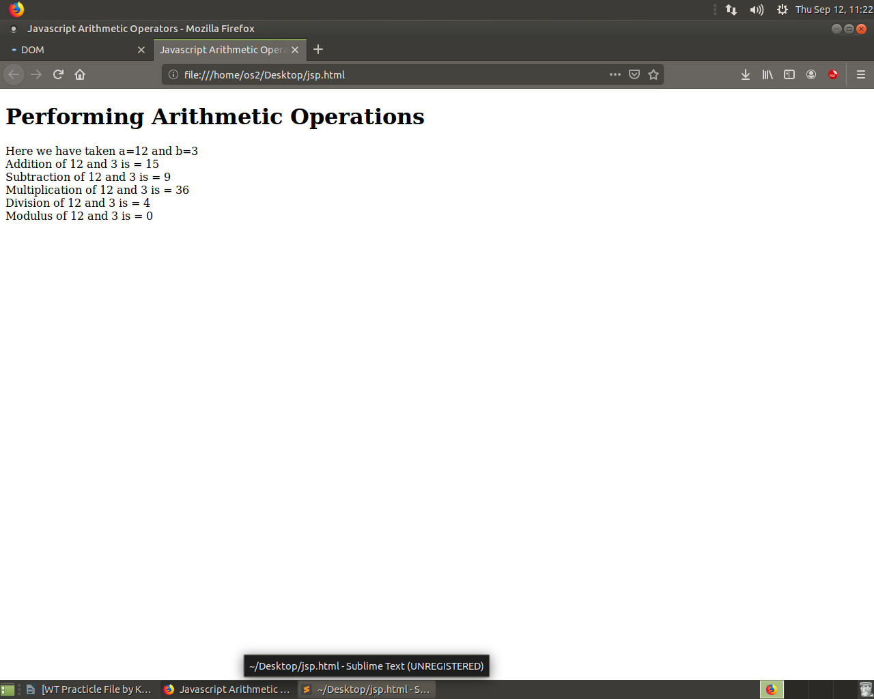

**Experiment 13.**

**Create an HTML file to implement alert,confirm,dialog box using javascript.**

Following code will implement alert,confirm,dialog box using javascript.

**<!DOCTYPE html>**

**<html>**

**<body>**

**<h2>JavaScript Alert,confirm & Prompt</h2>**

**<button onclick="myFunction()">Try it</button>**

**<p id="demo"></p>**

**<script>**

**function myFunction() {**

**var txt;**

**var person = prompt("Please enter your name:", "Harry Potter");**

**if (person == null || person == "") {**

**txt = "User cancelled the prompt.";**

**} else {**

**txt = "Hello " + person + "! How are you today?";**

**}**

**document.getElementById("demo").innerHTML = txt;**

**}**

**</script>**

**</body>**

**</html>**

**Output:>**